The Story of the Bible Summary

The Bible story starts with God’s creation of the heavens and earth. On the sixth day he created Adam and Eve and commands them to be fruitful and multiply on the earth. It does not take long before they have fallen into sin and are banished from the garden of Eden. The situation on the earth became so bad that God decided to wipe out everything by a flood - an object lesson of God’s judgment on human wickedness and of His mercy to Noah, his family and later generations. When they left the ark, God made a covenant with him to reinforce the command to Adam to be fruitful and multiply. The incident of the building of the tower of Babel is recorded as an example of divine judgment on human pride, leading to the scattering of the nations.

Around 1900 BC, God called Abraham and Sarah, from the city of Ur at the head of the Persian Gulf to travel through Canaan and, because of famine, on into Egypt. God renewed the covenant to Abraham and later confirmed it to his sons Isaac and Jacob, promising that they would inherit Canaan. Abraham took Hagar as his concubine and Ishmael was born. God made a covenant with him renewing his promise that Sarah would have a son, and gave him the covenant sign of circumcision. God destroyed the cities of Sodom and Gomorrah but, for Abraham's sake, allowed Lot to escape. God's promise to Abraham was fulfilled when Isaac was born and years later God tested Abraham's faith by asking Abraham to offer him as a sacrifice. At the last minute the Lord provided a substitute. Before his death Abraham made sure that Isaac was married to Rebecca, a distant relative from the home in Haran.

God chose Isaac's second son, Jacob, to be the heir, even though he was a cheat and stole his brothers birthright. The Lord wrestled with him at Peniel and anticipating a change in his character changed his name to Israel. Again God renewed the covenant he had made with Abraham. Jacob had twelve sons, the forerunners of the twelve tribes. But two of them were favourites: Joseph and, later in life, Benjamin, the youngest. Jacob's partiality for Joseph and Joseph's naivety provoked the hostile jealousy of the other brothers and they sold Joseph to travelling Ishmaelites. He become a slave in the house of the Egyptian Pharaoh and was put in prison on the lying evidence of Pharaoh's lustful wife. The jailer gave him responsibility and after several years in prison he predicted the coming famine and advised Pharaoh to prepare for it. Pharaoh made him Governor of Egypt. When the famine hit Canaan Joseph's brothers went up to Egypt to buy food. They met Joseph, who eventually arranged for Jacob and the whole extended family to settle in Goshen in north-eastern Egypt. Jacob was taken to Canaan for burial and Joseph ordered that when God kept his promise to lead them out of Egypt they should take his body with them. Joseph become a very senior administrator in Egypt and died there. A new king who did not know about Joseph came to power in Egypt and the Israelites were used as slave labour. As the years passed, their bondage became crueller and harder to bear. The stay in Egypt lasted for 430 years.

The people of Israel cried out to God for deliverance and He raised up Moses to deliver them. After a show down with Pharaoh with ten plagues, a dramatic departure included the celebration of the Passover and the miraculous crossing of the Red Sea. The escaping Israelites met God at Mt. Sinai where they camped for almost a year. Here God gave Israel a renewed covenant, a moral law and a sacrificial system. The tabernacle was built a year after the Israelites' escape from Egypt. Israel developed into a holy nation in covenant with God and an army ready to march into the promised land. The joy of setting out for the promised land was short-lived as the people began to complain about the shortage of food and longed for what they had enjoyed in Egypt. The twelve scouts that Moses sent out to survey the land of Canaan concluded that its inhabitants were invincible, but two of the spies, Caleb and Joshua, urged the people to obey the Lord and enter the land. God's judgment fell on His people and none of that adult generation entered the land of promise, except Caleb and Joshua. A journey that should have taken a year or two took forty years as they wandered in circles. Moses preached his last sermon to the people and died without entering the promised land. He had appointed Joshua to succeed him and to lead the people into the promised land. The Israelites crossed the Jordan river by a miracle of God and encountered the walled city of Jericho and destroyed it without a siege. The people eventually succeeded in conquering the land and it was allocated to the Israelite tribes as inheritance. The nomadic way of life of the patriarchs was replaced by a settled farming life in a new land. Other gods were already worshipped in the land and a long battle of loyalties between Yahweh and the Canaanite gods took place.

Israel failed to obey God's command to destroy the inhabitants of Canaan and the following cycle, described in the Book of Judges, occurred for 200 years: backsliding, oppression, deliverance through judges that God raised up and then backsliding again. The greatest judge was Samuel. When he grew old the elders of Israel came to him at Ramah and demanded he appoint a king to govern them. As Samuel prayed about their request, he realised they had rejected God and not him. The people refused to listen despite Samuel's efforts to warn the people that future kings would oppress them.

Saul, Israel's first king, began his reign with great promise. He was not so successful against the Philistines and when David slew the Philistine giant Goliath he became jealous. Because of his disobedience to the commands of God he fell in battle against the Philistines. David spent the latter years of Saul's reign fleeing from him. He began his own reign in Hebron, where the men of Judah anointed him king. He later moved his capital to Jerusalem and brought the ark there. He united Israel and made the country safe by winning victories over the Philistines, Edomites, Moabites, Ammonites and Syrians. Despite these conquests he had to endure rebellion at home from his son Absalom. Having built a palace for himself in Jerusalem, David wanted to build a house for the Lord. But God, God would not allow it. His son, Solomon, would be the one to build the temple.

King Solomon was gifted in administration and building and through his God-given wisdom he divided the country into twelve regions. He fortified cities and built up the army. But Solomon did not love the Lord with all his heart. His harem of foreign princesses turned his heart after other gods. He was only to maintain his building programme and lifestyle by oppressive measures, with high taxation and forced labour. When the people made his son, Rehoboam, king, they asked for the load to be lightened. Solomon's counsellors advised Rehoboam to be a servant to the people but when he added to their burden the ten northern and eastern tribes proclaimed their independence. From about 1050-930 BC there had been a united kingdom. But now the kingdom was divided. The northern kingdom was Israel, with Jeroboam its first king and its capital city Shechem (later changed to Samaria). The southern kingdom was Judah, with Rehoboam its first king and its capital city Jerusalem. Israel had several changes of dynasty and lasted just more than 200 years until the destruction of Samaria in 722 BC. Judah was more stable, retaining the dynasty of David throughout its longer history of about 350 years until Jerusalem was destroyed in 586 BC. During the time of the united kingdom under David and Solomon the books of poetry were written. This group of books includes Job (probably written during the time of the patriarchs), Psalms, Proverbs, Ecclesiastes and Song of Solomon.

The first ruler of the Northern Kingdom (Israel) was Jeroboam, who wanted to stop people going to Jerusalem on pilgrimage. So he made two alternative sanctuaries, one in the north at Dan and another in the south at Bethel, and installed in each a golden calf. In this way he caused Israel to sin. In 881 BC, 28 years after Jeroboam's death, the dynasty of Omri began. He established his capital in Samaria, and made it almost impregnable on a fortified hill. Yet he brought great trouble to Israel by marrying his son Ahab (who soon succeeded him) to the Phoenician princess Jezebel. She was a worshipper of Baal and insisted on maintaining a group of prophets of Baal. She involved her husband, the king, in her idolatrous worship and killed the prophets of the Lord. This apostasy began the ministry of prophets. The first prophet, Elijah, accused Ahab of troubling Israel by his religious defection and challenged the prophets of Baal to a public contest on Mt. Carmel. When Baal's prophets failed to get a response from their god, Elijah prayed that God would be known in Israel as God. God was vindicated! Later, Jehu, an Israelite army commander anointed king by the prophet Elisha, got rid of the house of Ahab and delivered the land of Baal worship. Jehu’s dynasty lasted nearly a hundred years (841-753 BC) during which time Syria took the whole of Transjordan from Jehu. Yet his grandson began to recover it and his great grandson, Jeroboam II, completed the process. Unfortunately peace brought prosperity, which led to luxury and then to license. While the sanctuaries were filled with pilgrims, and it seemed that Israel was experiencing revival, the prophets saw the injustice and immorality of the nation's leaders. The prophet Amos denounced Israel's hypocrisy and warned that God detested religion divorced from morality. The prophet Hosea stressed that God wanted faithfulness to the covenant, not just outward religion.

When the dynasty of Jehu ended, the northern kingdom had about thirty years left. A succession of military rulers occupied the throne, but the great Assyrian empire had arisen. The king of Assyria, Tiglath-Pileser III (745-727 BC), called Pul, embarked on a series of military campaigns. When he reached Israel, he was bought off by King Menahem with a thousand talents of silver. A few years later the ruler of Israel, Pekah the son of Remaliah, made an alliance with Rezin King of Syria to throw off the Assyrian yoke. When Ahaz King of Judah refused to join them, they invaded his territory. Ahaz was thrown into a panic, but the prophet Isaiah tried to calm him with a word from God. Ahaz did not believe. Instead, he appealed to Tiglath-Pileser for help, with devastating results. Syria was overthrown, the Galilean and Transjordan territories of Israel were depopulated and Ahaz paid homage to Tiglath-Pileser with silver and gold from the temple, and to Ashur, Assyria's god. When Tiglath died, Samaria withheld tribute from Assyria. This act sounded the death of Israel. The new King Shalmaneser V laid siege to Samaria, which capitulated three years later (722) to his successor Sargon II. He largely deported the people of Israel and colonized their country with Syrians and Babylonians. The resulting mixed population was the origin of the Samaritans. So the northern kingdom ended, having lasted just over 200 years. Israel had thought that God's covenant made her immune to His judgment.

The Southern Kingdom (Judah) continued alone for another 135 years - its independence maintained by two religious reforms. The first promoted by King Hezekiah and encouraged by the prophets Isaiah and Micah and the second promoted by King Josiah and encouraged by the prophet Zephaniah and the prophet Jeremiah. Hezekiah repaired and reopened the temple. He removed all the elements of Assyrian idolatry and introduced genuine reforms. Sargon, King of Assyria, was killed in action in 705 BC and was followed by his son Sennacherib. Hezekiah decided to revolt against Assyrian rule. Sennacherib only reached the rebel kingdom of Judah in 701 BC. He took the fortified cities and laid siege to Jerusalem. Fortunately, Hezekiah had secured the city's water supply with a tunnel from a spring outside the walls to the Pool of Siloam. God delivered the nation!

The half-century after Hezekiah's death was a time of religious apostasy. His son Manasseh reintroduced the Canaanite and Assyrian worship that Hezekiah had destroyed. His son Amon who reigned only two years was no better. But good King Josiah who reigned from 639 to 609 BC brought about reforms prompted by the discovery of the book of the law in the temple. He got rid of the pagan religions, renewed the nation's covenant with God, had all objects of Assyrian and Canaanite worship removed from the city and the provinces, closed down the local sanctuaries, prohibited spiritism and human sacrifice and ordered the Passover to be celebrated in Jerusalem.

Jeremiah was encouraging the reformation but he said they were superficial. He was proved right when Josiah's reform did not last and his son Jehoiakim quickly succeeded in undoing his good work. Jeremiah had to go into hiding. In 616 BC Assyria was invaded by Babylonia and Nineveh, the Assyrian capital, fell after a siege. The Book of Jonah illustrates how reluctantly an Israelite would contemplate Nineveh's repentance and forgiveness, and the prophet Nahum expresses the widespread reaction to Nineveh's oppression. Jerusalem was besieged and captured and three thousand members of the nobility were taken captive to Babylon with the temple treasures. Among the exiles was Ezekiel who had foretold the departure of God's glory from the temple because of Judah's sin. Nebuchadnezzar appointed Zedekiah, another of King Josiah's sons, to the throne of Judah. He was weak and indecisive, and looked to Egypt for help despite Jeremiahs warning to submit to Babylon. In 589 BC Zedekiah openly rebelled against Babylon. The help from Egypt did not materialised and Jerusalem was sieged again and fell in 586 B. The city walls were reduced to rubble and Solomon's temple was burned to the ground. The tiny remnant who were left were put in the charge of Gedaliah. When he was assassinated the survivors fled to Egypt, dragging Jeremiah with them. Israel's despair is recorded in the book of Lamentations. The Babylonian captivity lasted for fifty years. Although the exiles had been deported from their homes, they enjoyed considerable freedom. Their hardest trial was religious, as they felt spiritually lost being separated from the temple and sacrifices. But Ezekiel was among them and he spoke the word of the Lord to them.

In 559 BC Cyrus II became king of the nearby Persian empire. Nine years later he became King of Media as well and ‘the Medes and Persians' were united. In 546 BC he defeated the king of Lydia and Asia Minor was added to his empire. The Jewish exiles must have heard of the exploits of Cyrus with growing expectation that their own deliverance from Babylon would come soon. They knew that God was going one day to redeem them, for their prophets had always added visions of hope to their warnings of doom. Through the prophet Isaiah, God had said that Cyrus would be the deliverer.

In 539 BC Belshazzar King of Babylon saw the handwriting on the wall and that night Babylon fell into the hands of the Persians. Cyrus issued two decrees: authorizing the Jewish exiles to return home and to rebuild their temple. The Jewish exiles were filled with relief and joy when the news of their deliverance reached them, but not all the exiles took advantage of the decree and a large number remained. The book of Esther tells the story of some of them during the reign of Ahasuerus. The restoration took place in three stags: First, Zerubbabel returned (538 BC) to restore the temple, Ezra (458 BC) to restore the laws and Nehemiah (445 BC) to restore the city walls.

Israel had to wait another 400 years for the birth of her Messiah. This is called ‘the inter-testamental period', as no book of either the Old or the New Testament was written during it - the voice of prophecy was silent. The First Book of the Maccabees describes the events of 175-134 BC, calling it a time of great affliction for Israel. The period can be divided into six stages: Persian supremacy (539-331); Greek supremacy (331-323); Greek Ptolemaic-Egyptian supremacy (320-198); Greek Selucid-Syrian supremacy (198-142); the Hasmoneans (142-63) and Roman supremacy (63-).

After 400 years of silence, God revealed Himself in two ways: through the coming of Jesus Christ, His Son, and through the writing of the New Testament. The world had changed greatly during those 400 years of silence. Rome was the dominant force in the first-century world. Its armies had marched with power and precision across Europe, the Middle East, and Africa, bringing nation after nation under its control. Palestine had fallen to General Pompey in 63 BC. Though taxed heavily, Israel benefited from Roman rule: peace - the world was at peace in the days of the New Testament; government - the emperor had the power to force reigning governors to rule well, which kept them from gaining private wealth at the expense of the people; travel - because of the Roman peace, people could travel freely from country to country; and communication - the flow of information was the best the world had ever known. Although the Greek Empire had collapsed before New Testament days, it was still a powerful world influence in two ways: Language and Culture. The Jewish background of the New Testament was important because Christianity was born in a Jewish environment, and it was rooted in what God had already made known to His people through the Old Testament.

The New Testament story begins with the cry of a newborn baby. In Bethlehem of Judea, a son was born to Joseph of Nazareth and his young wife Mary. It was a virgin birth, prophesied in the Old Testament, announced by angels, and made possible by a miracle. When it came time for Mary to deliver, she and Joseph were in Bethlehem, "the city of David", miles away from home because Rome had demanded that everyone in Palestine enrol for the tax in the city of their lineage.
‘

John the Baptizer appeared on the scene and began to preach, calling the Jews to repentance in preparation for the kingdom of God. One day, while John was baptizing in the Jordan River, Jesus came and insisted on being baptized. While He was in the water, the Holy Spirit descended on Him like a dove and the Father in heaven voiced His approval. The next day, Jesus was led by the Holy Spirit into the wilderness where He was tempted by Satan. After this, Jesus began to make Himself known to the people. His three years of public life were marked by three major activities: teaching, performing miracles, and training His apostles. The Sermon on the Mount was Jesus' first great teaching session. His teaching was accompanied by miracles. He demonstrated that His claim to be the Son of God was true by showing His power over nature, demons, disease, and even death. Jesus chose twelve men to be His disciples. During the last two years of His public ministry, these men were with Him nearly all the time. Crowds flocked to Jesus and he soon became popular. The religious leaders of Israel hated Him and began to plot His death. As His ministry drew to a close, even the crowds forsook Him. His enemies grew more bold. Finally, one of His own disciples conspired to betray Him. Jesus travelled to Jerusalem at Passover and was celebrated by the common people. The next day, He threw the moneychangers out of the temple. He met with His disciples one last time in an upper room, and while they were assembled Judas left to betray Him. Jesus initiated the communion service before making His way to the Garden of Gethsemane to pray. There He was arrested by a mob and then given an illegal trial before the Sanhedrin, declared guilty, and brought before Pilate. When the Roman proconsul could not persuade the mob to release Him, he turned Him over to them. Jesus was led to Calvary, where He was crucified with two criminals.

When Jesus died, his body was claimed by two of His followers and placed in a new tomb. All seemed lost for Jesus' disciples. But three days later, He rose from the dead. He appeared privately to His disciples on several occasions, and was also seen by hundreds of others. He had conquered death! The last sight of Him was His ascension into heaven forty days after His resurrection.

The hopes of Jesus' disciples were crushed when Jesus died. His crucifixion had left them scattered and disillusioned. The news of His resurrection, however, brought them hope, and His appearance transformed them. From that little band of men, the church grew rapidly. The book of Acts tells the story of the beginnings of the church.

Before Jesus ascended to the Father, He told His disciples to wait in Jerusalem until the coming of the Holy Spirit. This happened on the day of Pentecost. The day they received that power, they began to proclaim Christ. Peter stood and addressed the crowd with great courage. The theme of his sermon was: you crucified your long-awaited Messiah, but God raised Him from the dead. When the people asked what they should do, Peter replied that they should repent and be baptised. About 3,000 people trusted in Christ, and the church began to grow.

With growth came opposition. Peter and John were arrested for preaching, threatened, and ordered to stop. But they refused to obey the order and prayed for even more boldness to preach. The Sadducees were jealous of the apostles popularity, so they had them arrested and imprisoned. After they were freed by an angel, the apostles were recaptured and brought before the Jewish council, where they were beaten and commanded not to preach. They told the council that they would obey God rather than men, and they continued daily in their preaching and teaching. The religious leaders hatred of the Christians finally focussed on Stephen. He was stoned to death. A man in that crowd named Saul held the garments of those who threw the rocks. He then took the lead in persecuting Christians, going from house to house and imprisoning men and women alike. The followers of Jesus fled Jerusalem, and wherever they scattered they took the gospel with them. Some went to Damascus, and Saul got permission to go and arrest them.

As Saul was travelling to Damascus, a brilliant light stopped him and forced him to the ground. A voice spoke to him from the light. When Saul asked who was speaking, Jesus identified Himself. In an instant Saul was converted. The antagonist became a believer and a great missionary to the Gentiles. With Barnabas, Silas, or Timothy, he went from city to city proclaiming Christ during three missionary journeys. Thousands believed and churches were established in private homes. After Paul moved on, he often wrote to the churches to confirm the believers in the faith, to correct their doctrine, or instruct them in Christian behaviour. The day came when Paul was arrested in Jerusalem and after appealing to his Roman citizenship was transported to Rome where he remained under house arrest for 2 years. But he was still able to preach and teach and correspond with the churches he had planted. The church had spread throughout the Roman world.

In the city of Corinth, a group of people responded to Paul's preaching, became Christians, and formed a church. But they were involved in immorality, division, and strife. In Philippi, a discouraged group of believers needed lifting up. In Rome, a loyal band of followers needed to clarify their beliefs about righteousness, the Law, and sanctification. The believers at Thessalonica needed to know about Christ's return and the last days. In Ephesus, the leaders needed instruction about their position in Christ. Elsewhere, Christians were suffering and didn't understand why. False teachers were infiltrating churches and threatening to undermine the work. A pastor at Crete needed encouragement. What was the best way to meet the needs of the growing church? The apostles couldn't be everywhere at once. So they sent letters (also known as epistles) to explain Christian teaching, to inspire God's people to holiness, and to tell them how to live. Copies were made with meticulous care and believers began to collect them. All in all, twenty one such letters were judged to be inspired, and they became a major portion of the New Testament.

The people under persecution were wondering what would come next. The answers came to John in a series of visions. Written down in the book of Revelation in figurative language, they set forth the future of the church and all mankind. In his first vision, John saw Christ, the Head of the church, walking among lampstands that represented seven churches of Asia Minor, to which he gave words of approval, accusation, or admonition. In his second vision, John saw the throne of God surrounded by worshippers who exalt God for His creation. When no one was found worthy to open a large scroll, John wept. He was told to stop weeping and was given the vision of a slain Lamb standing in the centre of the throne in heaven. A chorus of praise rang out for the Lamb, who was worthy to open the scroll because He had purchased men with His own blood. In his third vision, John saw into the future. This portion may be divided into three general sections: (1) The Tribulation (6-18) - here God's wrath was poured out on the earth in judgment. (2) The Return of Christ (19,20) - here John saw Jesus Christ return to earth in all His glory; Antichrist defeated at Armageddon and Satan chained for 1,000 years in the bottomless pit; Jesus reigning for 1,000 year reign over the earth; Satan released and revolting against the Lord; rebels destroyed by fire from heaven; Satan cast into the lake of fire forever; earth and heaven destroyed and replaced by a new heaven and new earth; and the resurrection of unbeliever are for judgement at the great white throne. (3) A Vision of Heaven (21,22) - John's vision concludes with a survey of the new heaven and new earth where believers will live in the presence of God and their Saviour-King, the Lord Jesus Christ, forever.

The Story of the Bible

The Old Testament

1. The Creation of the World
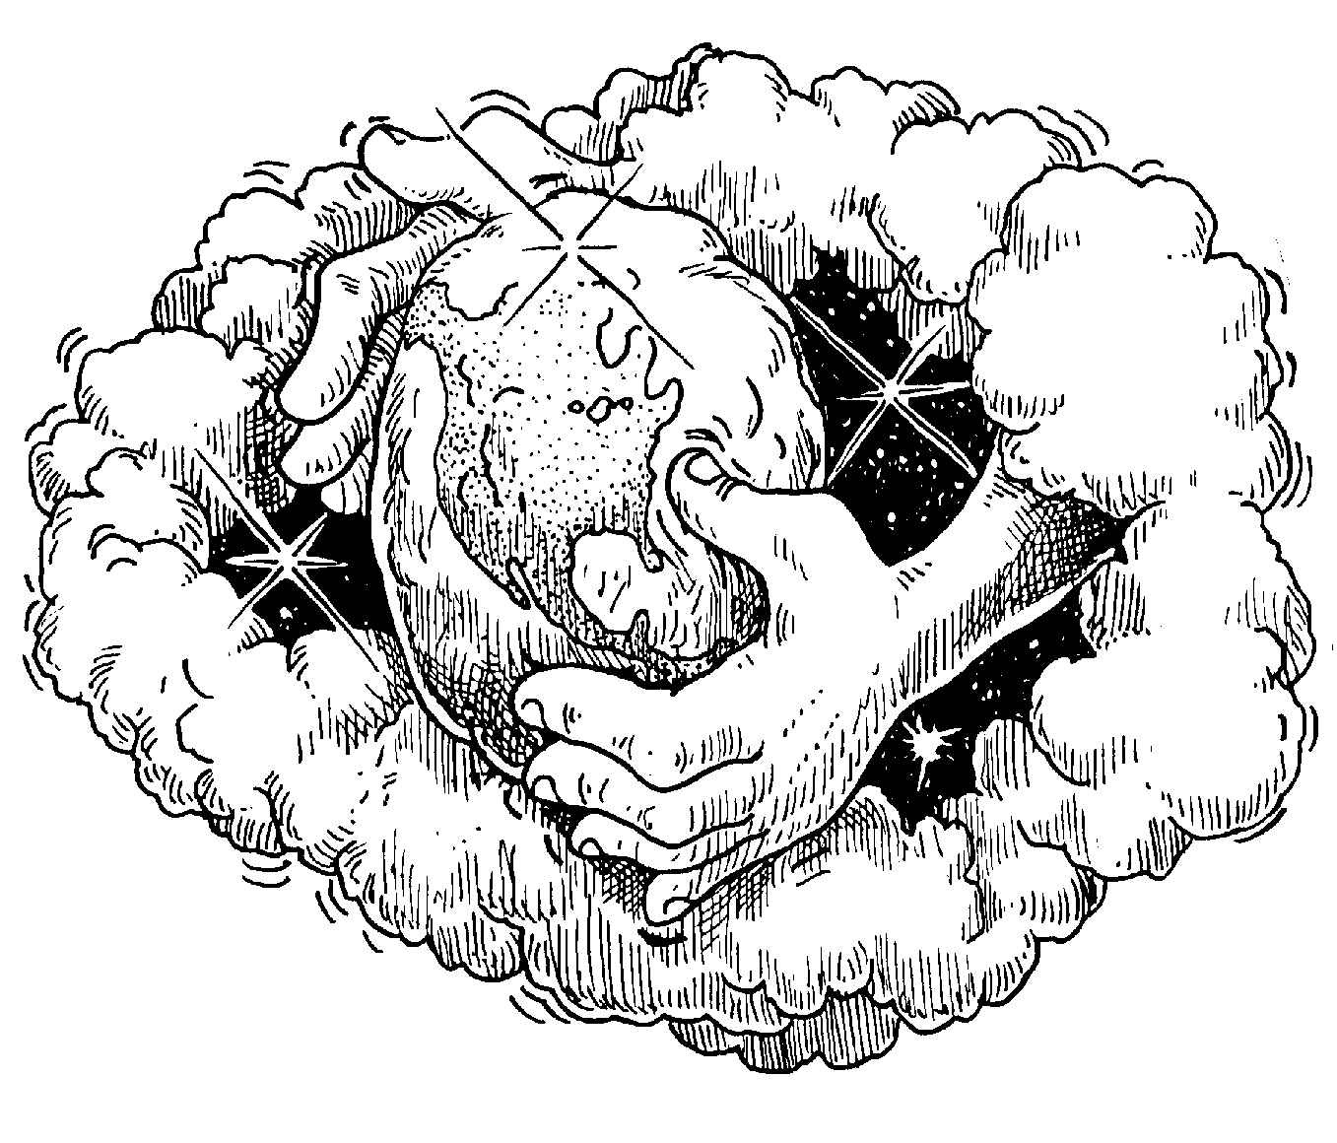

2. The Time of the Patriarchs

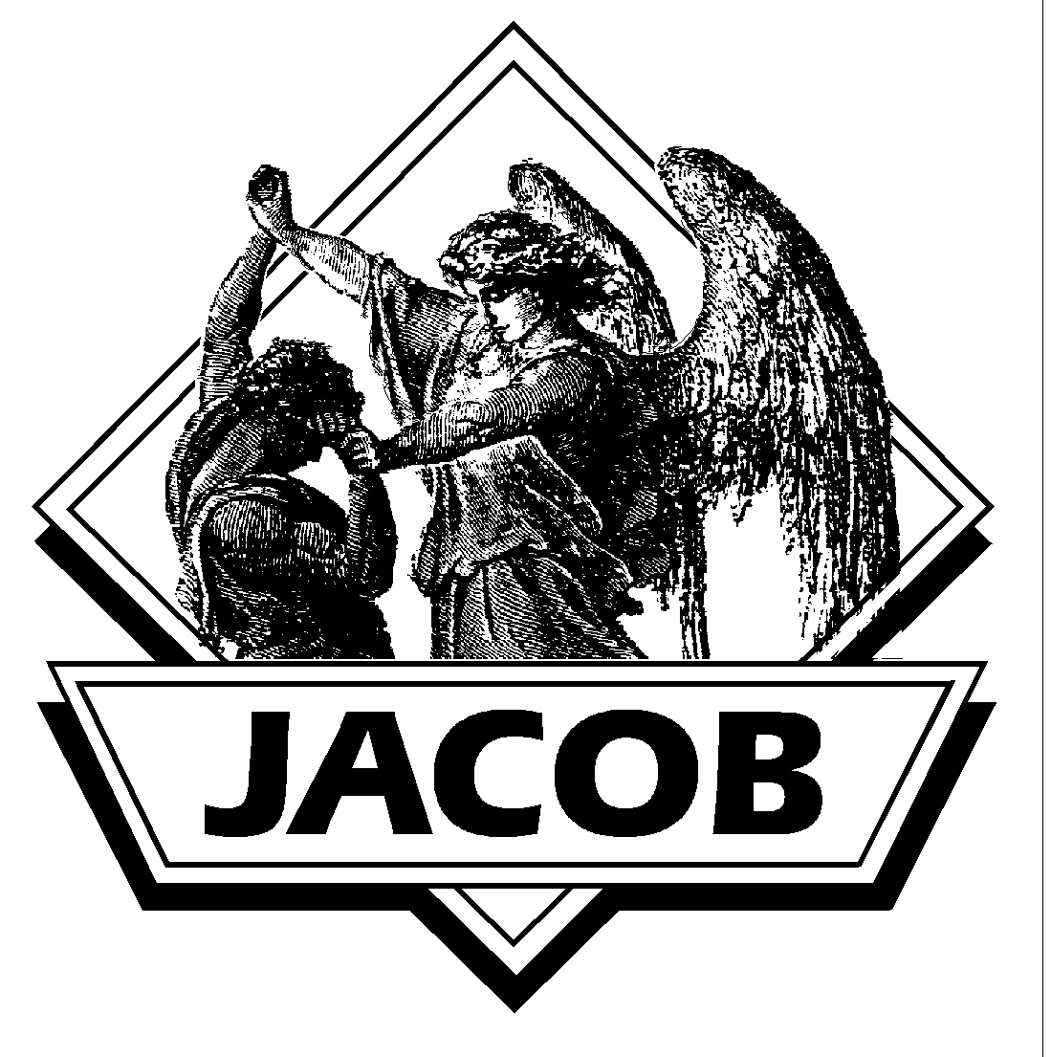





3. The Exodus from Egypt
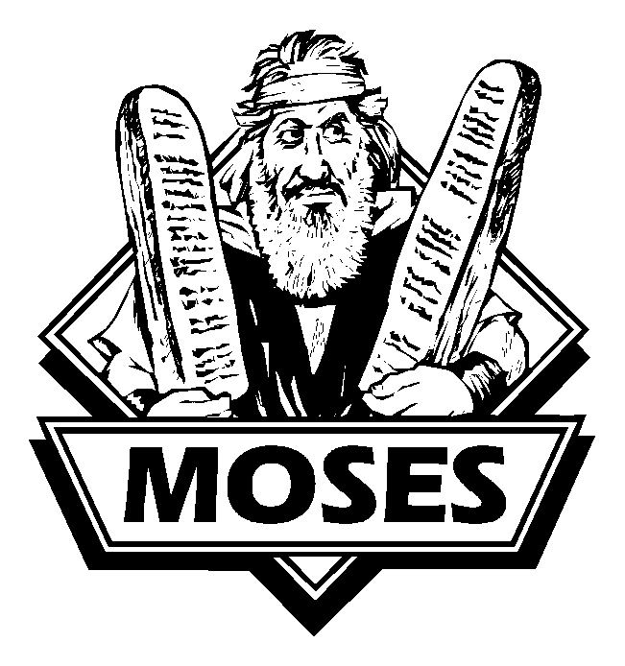

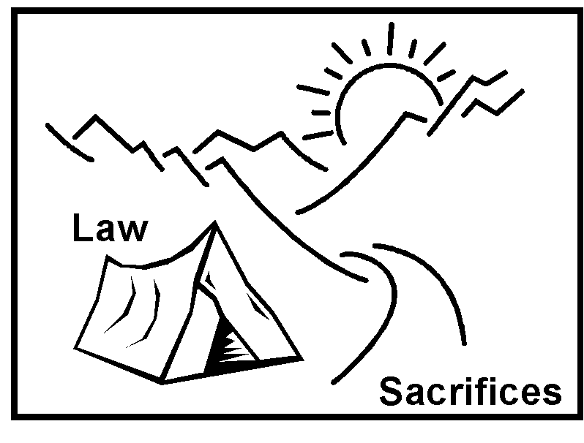

4. The Wilderness Wanderings

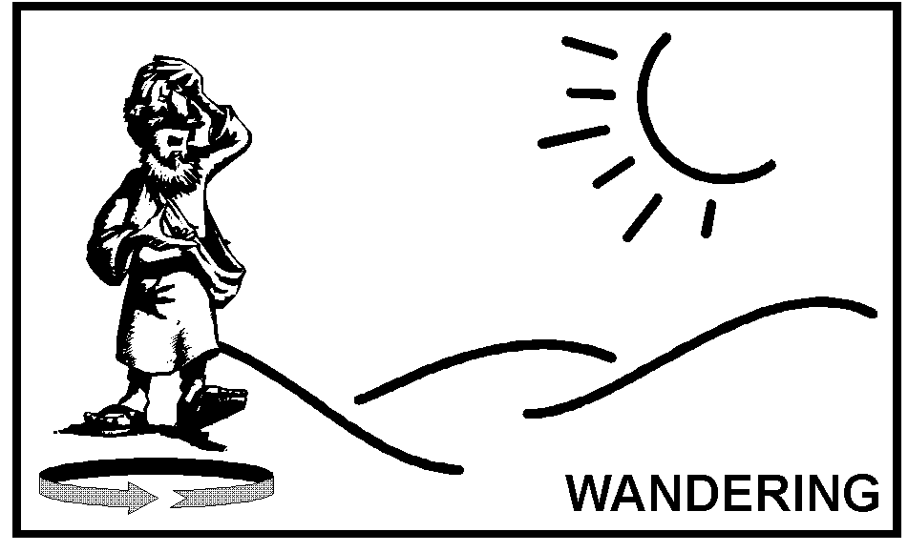

5. Israel’s Settlement in Canaan





6. The United Kingdom


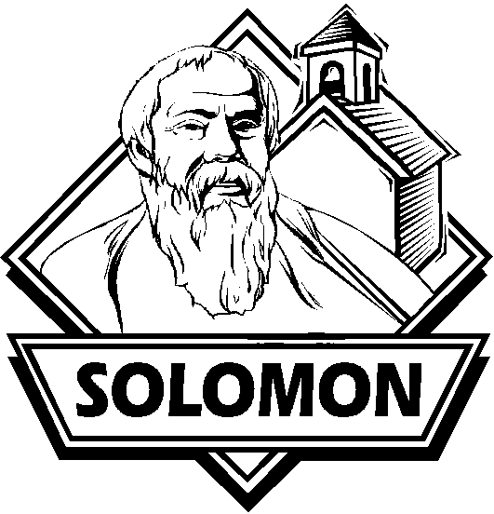

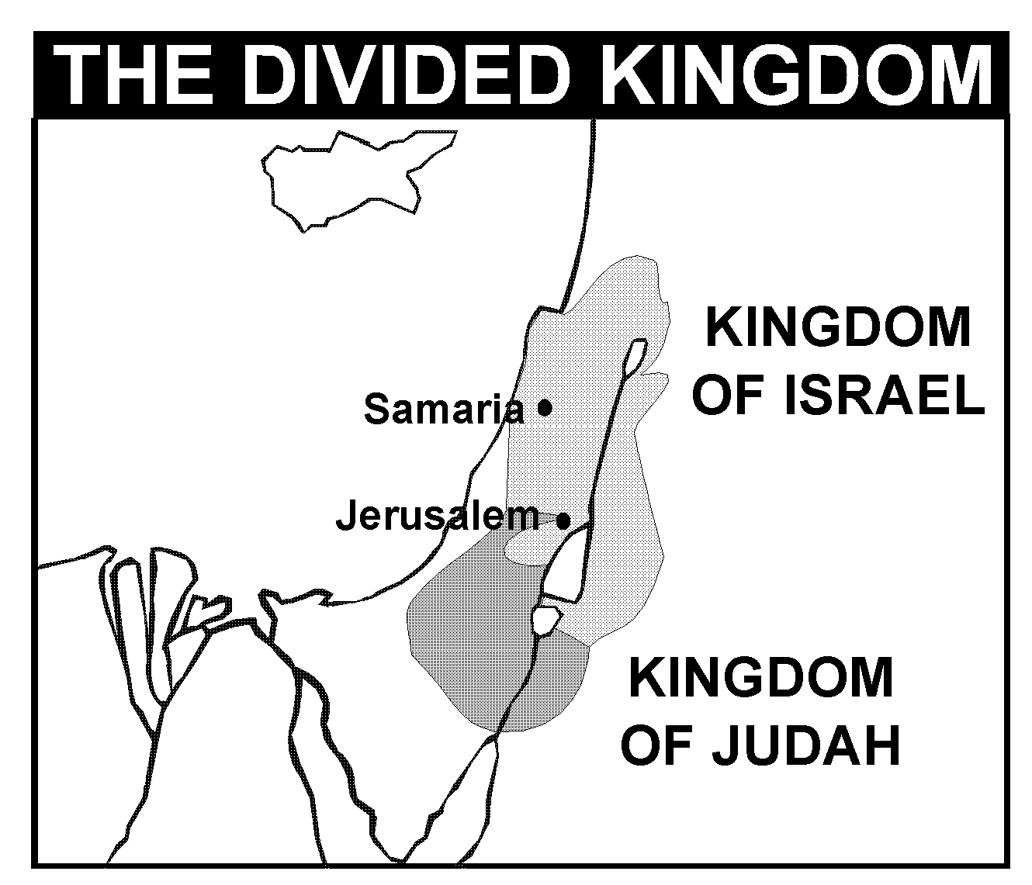

7. The Northern Kingdom (Israel)

8. The Southern Kingdom (Judah)

9. The Restoration from Captivity



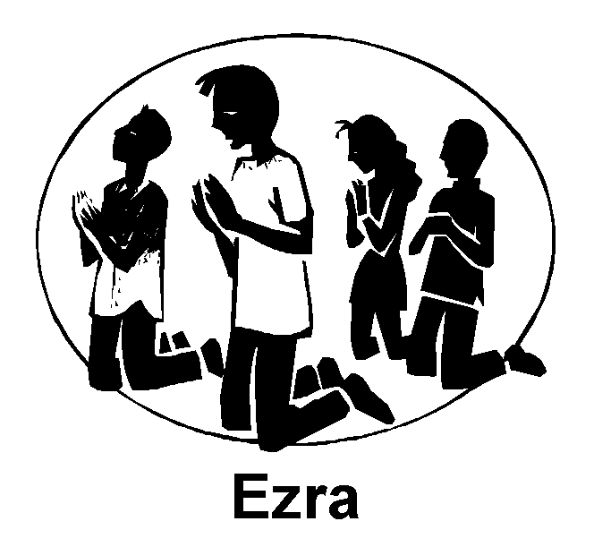

10. The Inter-Testamental Period

The New Testament

1. The Life of Jesus
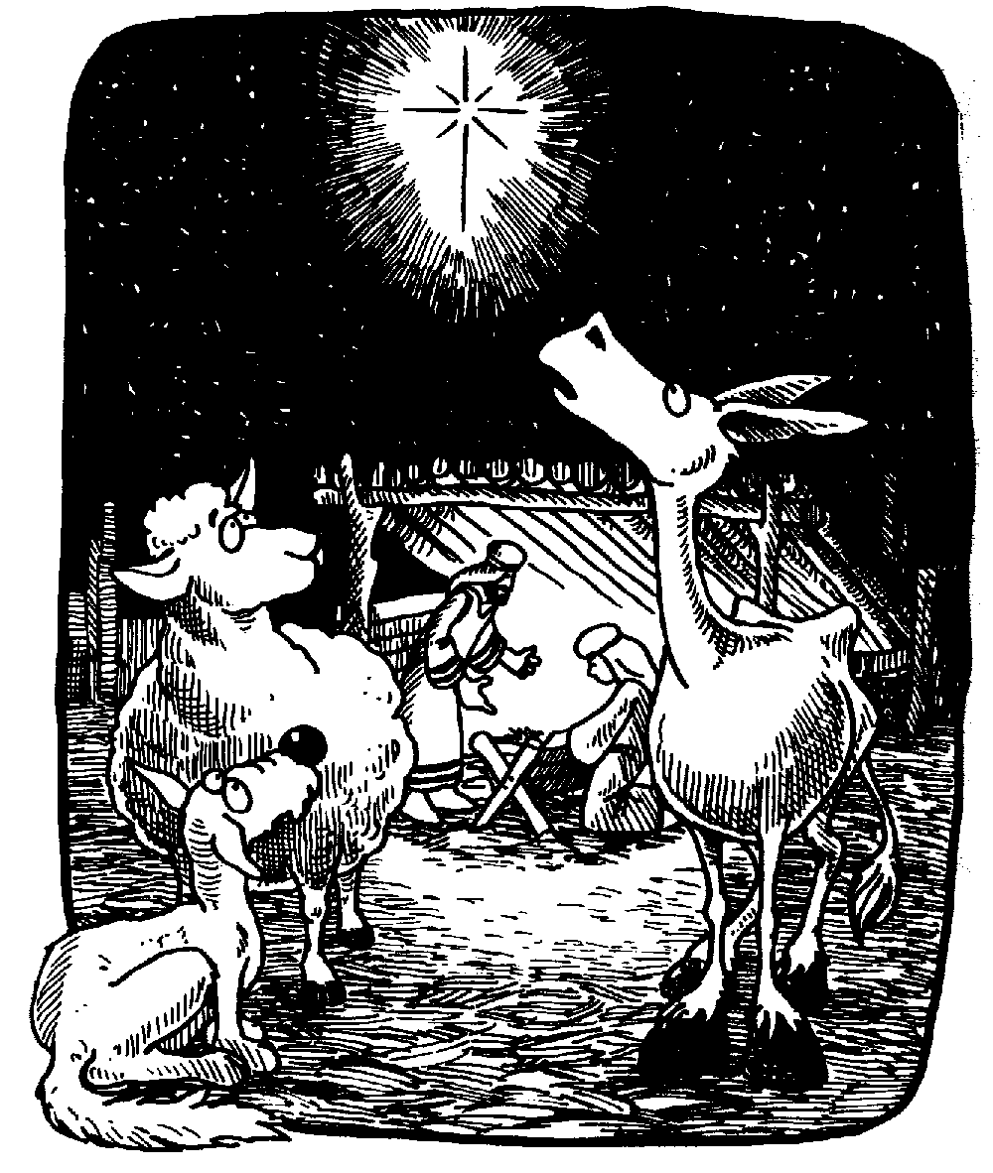
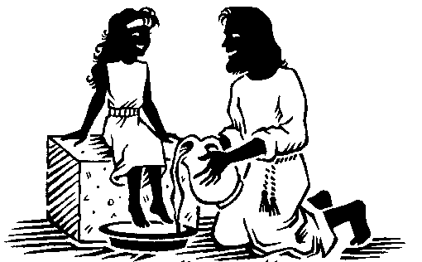

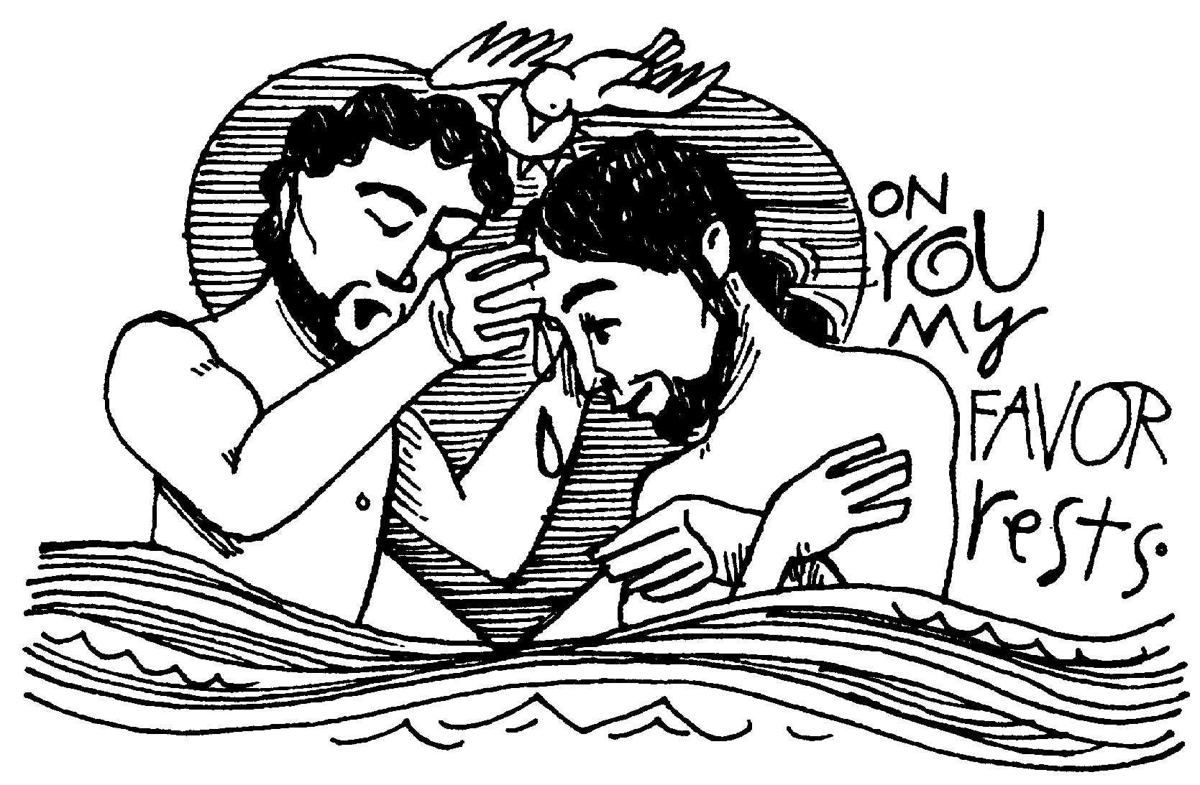

A. Jesus’ Birth B. Jesus’ Baptism C. Jesus’ Ministry

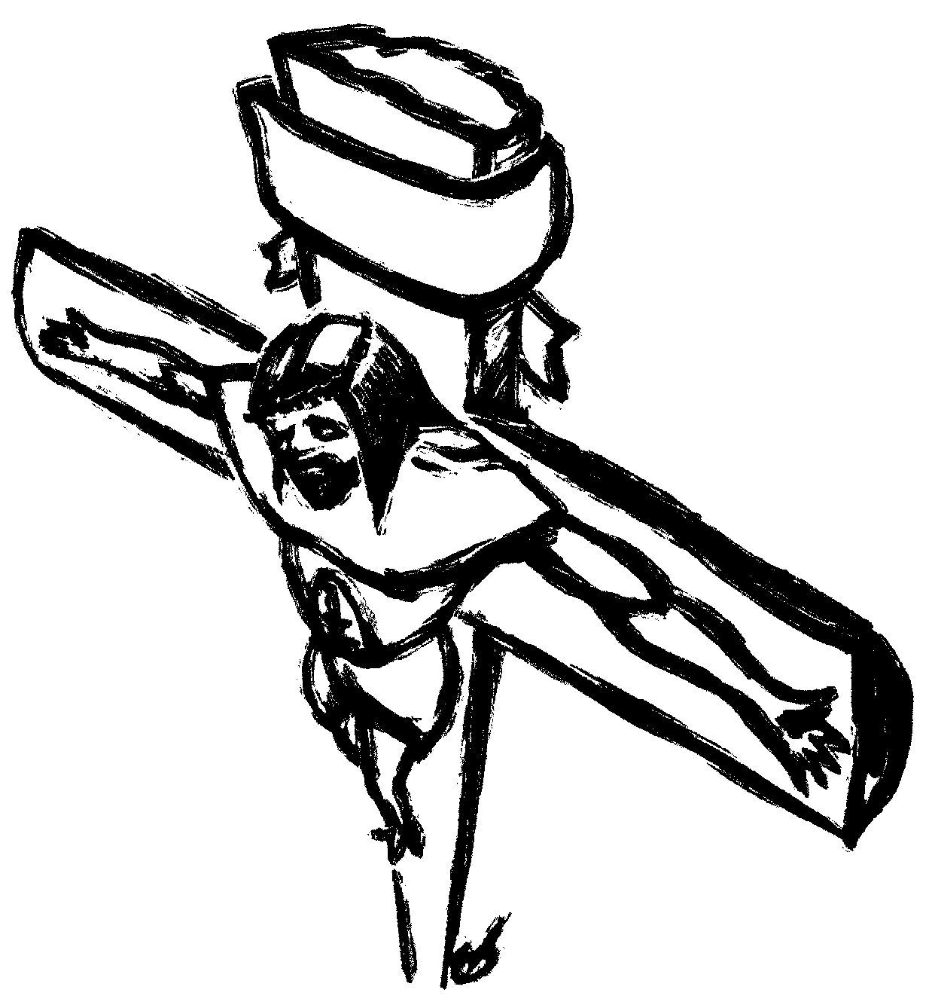



D. Jesus’ Death E. Jesus’ Resurrection

2. The Growth of the Church



A. Power (Acts 1-2:13)
B. Proclamation (2:14-3:26)
C. Persecution (Acts 4:1-8:3)
D. Paul (Acts 9:1-28:31)

3. The Journeys of Paul
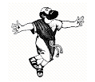

Paul’s First Journey (Acts 13-14)
From Antioch (Acts 13:1-4) to Seleucia (Acts 13:4) to Salamis (Acts 13:4-5) to Paphos (Acts 13:6-12) to Perga (Acts 13:13) to Pisidian Antioch (Acts 13:13-52) to Iconium (Acts 14:1-7) to Lystra (Acts 14:8-14) to Derbe (Acts 14:20-21) and to Attalia/Antioch (Acts 14:25-28).

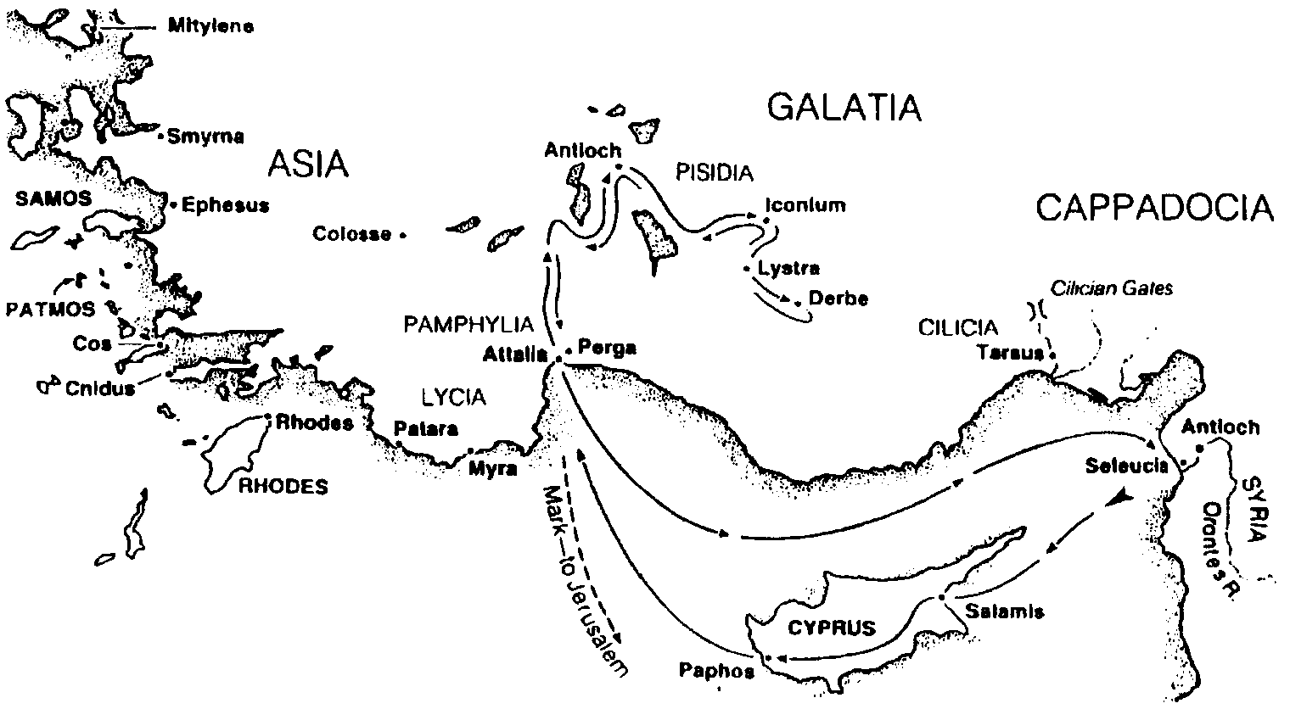

Paul’s Second Journey (Acts 15-18:22)
From Jerusalem (Acts 15:1-29) to Antioch (Acts 15:30-39) to Derbe (Acts 16:1) to Lystra (Acts 16:1-5) to Troas (Acts 16:6-10) to Neapolis (Acts 16:11) to Philippi (Acts 16:12-40) to Amphipolis/Apollonia (Acts 17:1) to Thessalonica (Acts 17:1-9) to Berea (Acts 17:10-15) to Athens (Acts 17:16-34) to Corinth (Acts 18:1-17) to Cenchrea (Acts 18:18) to Ephesus (Acts 18:19-21) and to Caesarea (Acts 18:22).
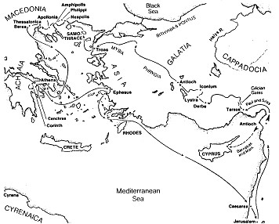

Paul’s Third Journey (Acts 18:23-21:16)
From Antioch (Acts 18:23) to Ephesus (Acts 18:24-19:41) to Thessalonica and Corinth (Macedonia and Greece) (Acts 20:1-6) to Philippi (Acts 20:6) to Troas (Acts 20:7-12) to Assos (Acts 20:13-14) to Mitylene (Acts 20:14) to Miletus (Acts 20:15-38) to Tyre (Acts 21:1-3) to Caesarea (Acts 21:7-14) and to Jerusalem (Acts 21:15-18).

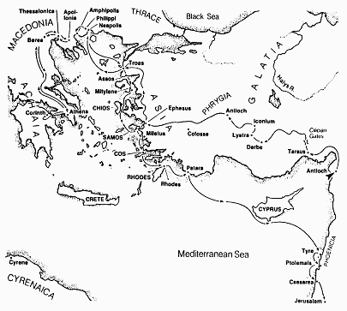

4. The Writing of Letters

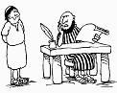

5. The Revelation of Jesus


A. John’s Vision of the Past (Rev. 1-3)
B. John’s Vision of Heaven (Rev. 4-5)
C. John’s Vision of the Future (Rev. 6-22)

